AEM doc-- US88446: [QA] [Enhancement] Product Switcher - CTA to have Download and Open in a new tab PDF Option
Product switcher component | https://author-p121905-e1193012.adobeaemcloud.com/ui#/aem/editor.html/content/gehealthcare/language-masters/en/product-switcher.html?appId=aemshell

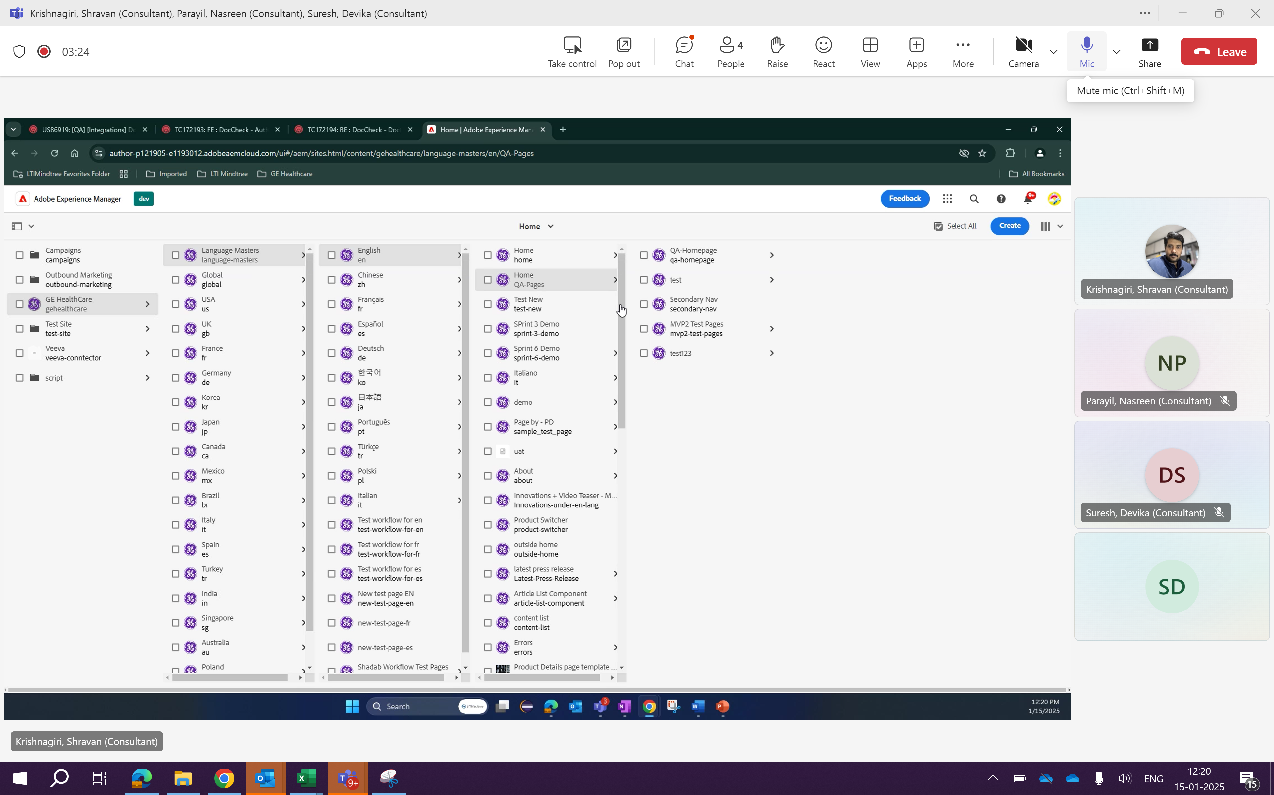

Product switcher:
Scenario 1: Download PPT:
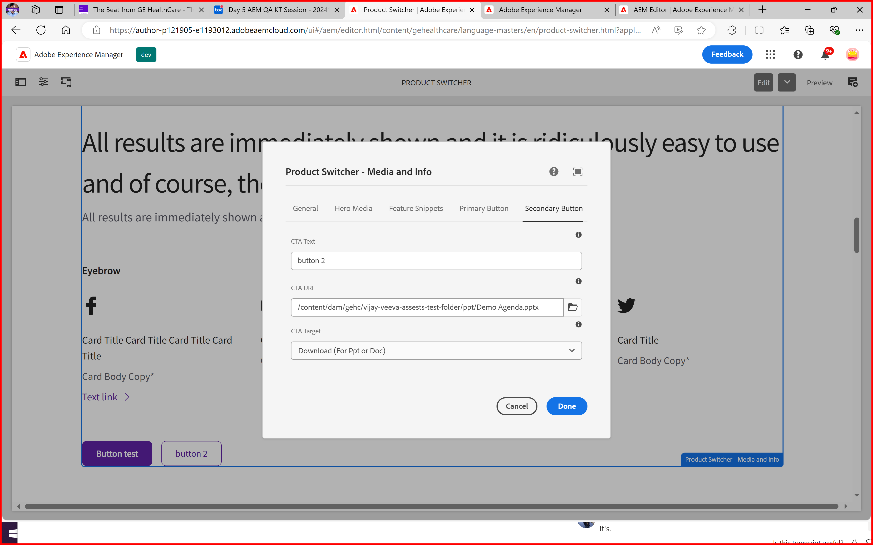
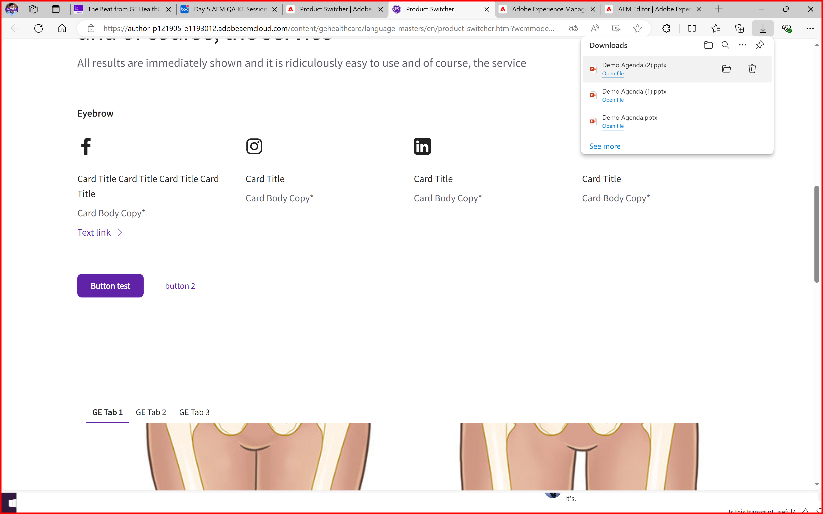

Doc.text format downloaded:
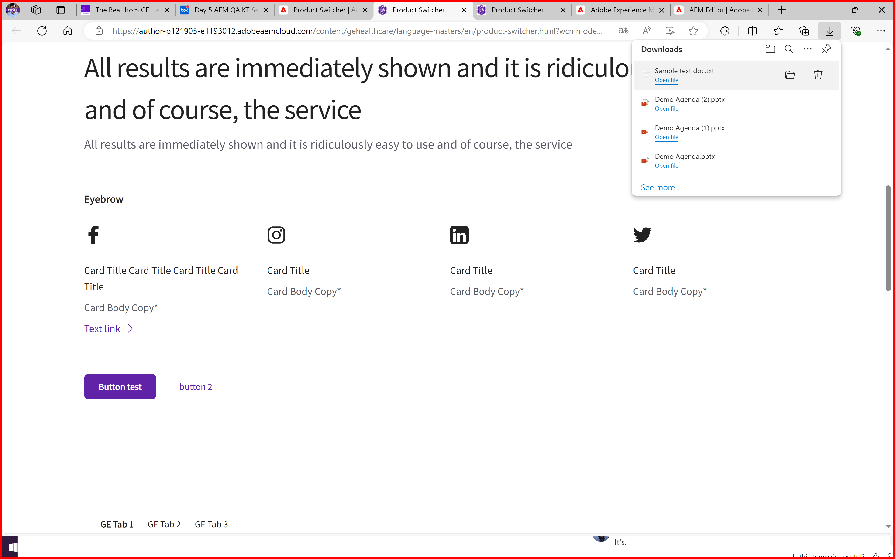

2nd Scenario: Open document in new Tab
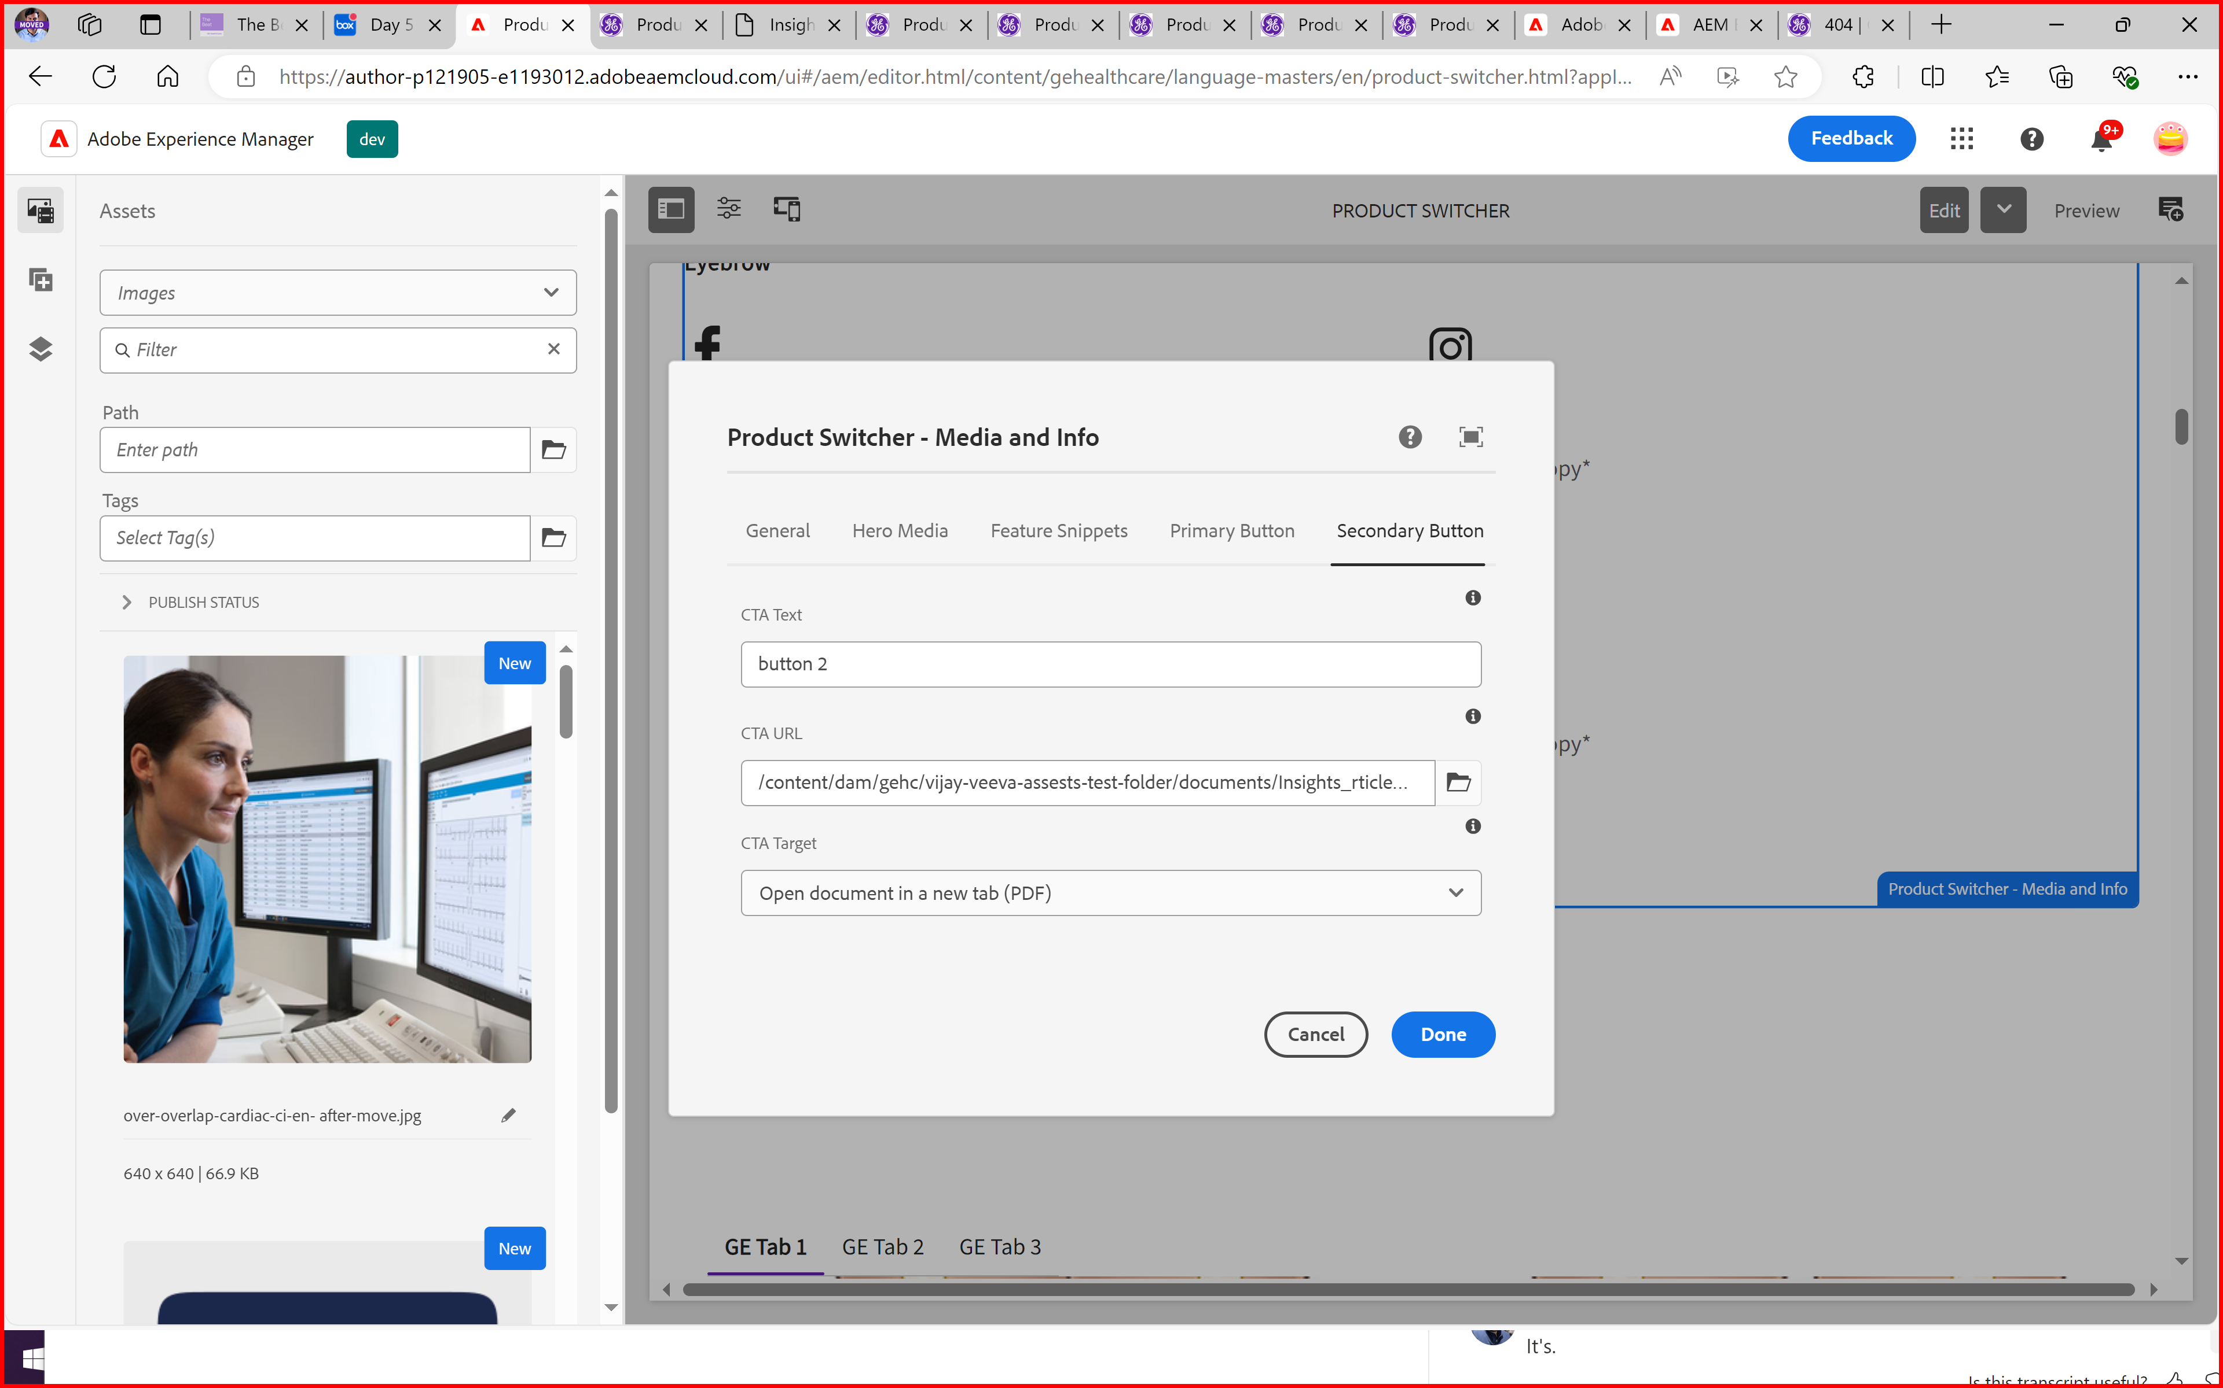

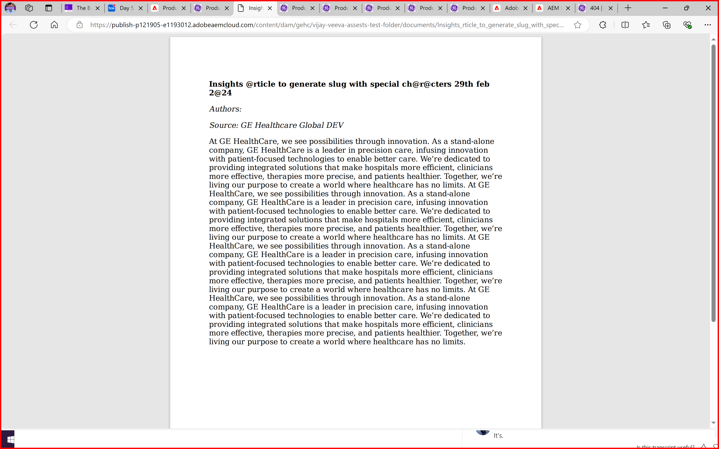

Existing Options:
testing existing component-open link in new tab

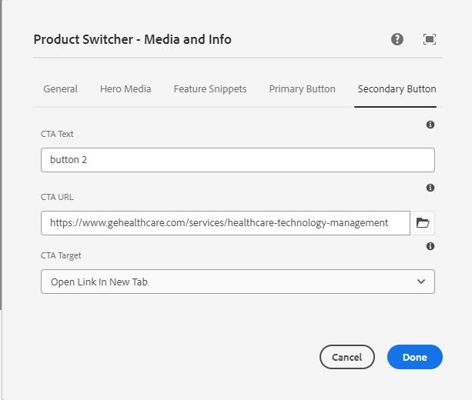
FE


testing existing component-open link in new window
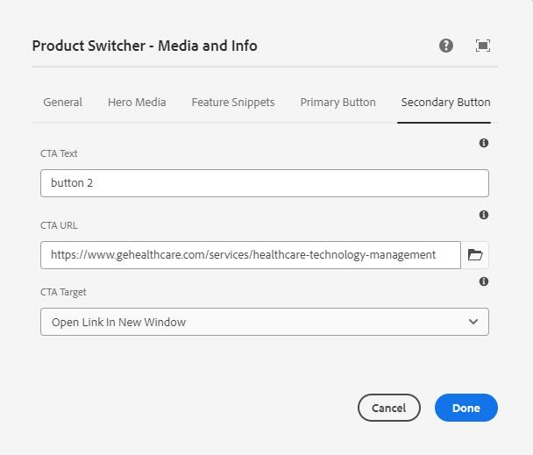
FE
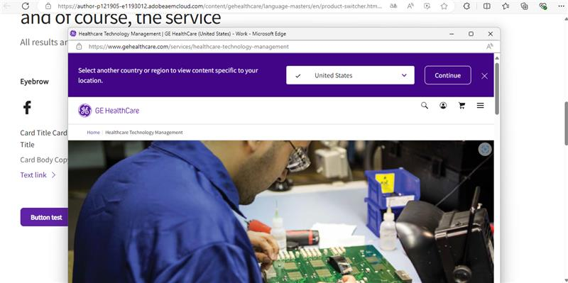

testing existing component-open a form
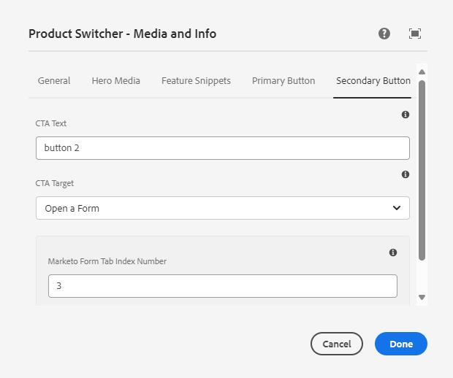
FE
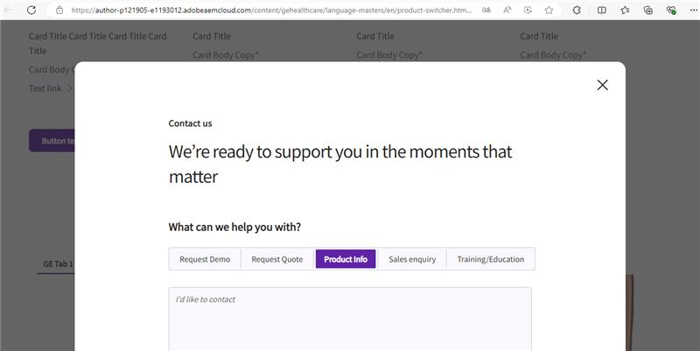

testing new component-Download ppt
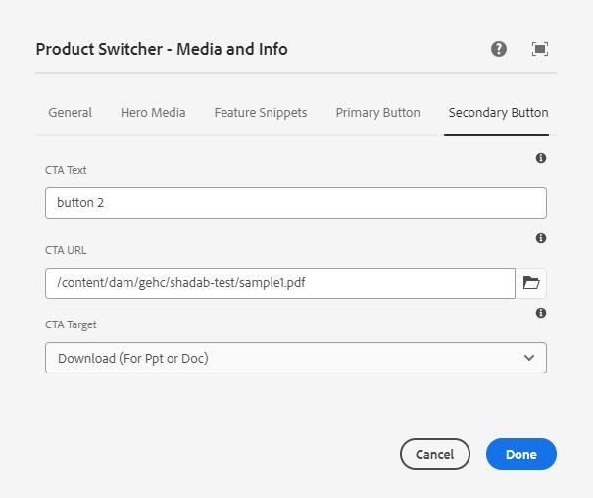
FE
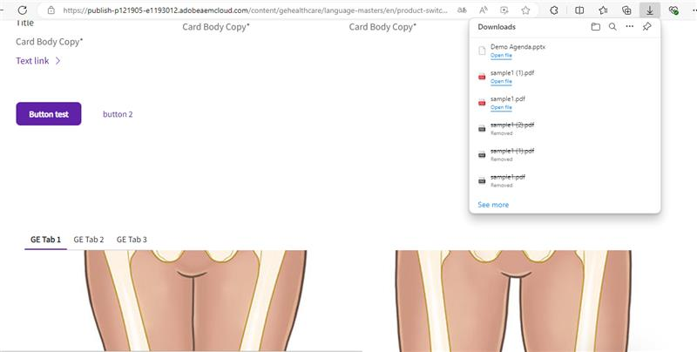

testing new component-Open pdf in new tab
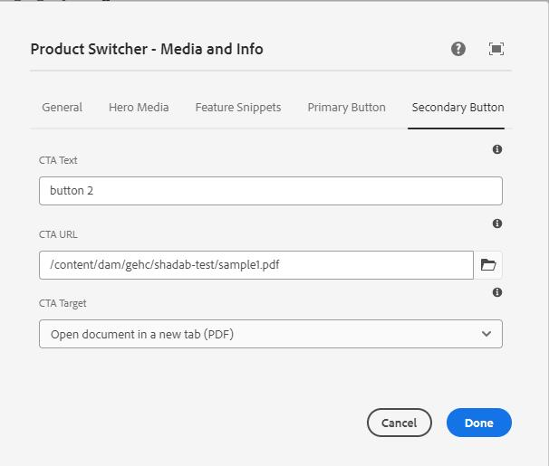
FE
